Self-Care Party Essentials

Host, have your guests check out the self-care treatment menu & choose which service they would like during your party. Each service costs $42 and is 30 minutes in length. Email this log sheet to kandichampion@gmail.com. I will then set the schedule of services and email you within one week of your party to insure all essentials are covered and all questions are answered. Please note the * indicates which services are safe for expecting mothers. If any of your guests are expecting, please be sure to note that next to their name. The menu is included in this packet for your convenience.

Please note that I only service to the bottom floor only, unless there is elevator access.

Please fill out all spaces for each guest entry. This information is needed to register to my booking software. Each guest will receive an email confirmation of their scheduled self-care treatment and an online intake form, which is required by law in order to perform massage services. Copy the 2nd page for additional guests. A Minor Release Form is also required for each minor guest attending your party.

Booking Policy: A credit card on file is required to book a party. Two weeks advance booking required. You will receive a complimentary phone consultation to ensure that all your questions and concerns are answered. One week prior to event, I’ll touch base via email for last minute questions and to send out required paperwork for each guest. Guests paying with a credit card must prepay their service online at least 24 hours prior to the party. Cash payments are received prior to time of service during the party.

Cancellation Policy: There is a $42 cancellation fee, if the party is cancelled 48 hours or less before the event date.

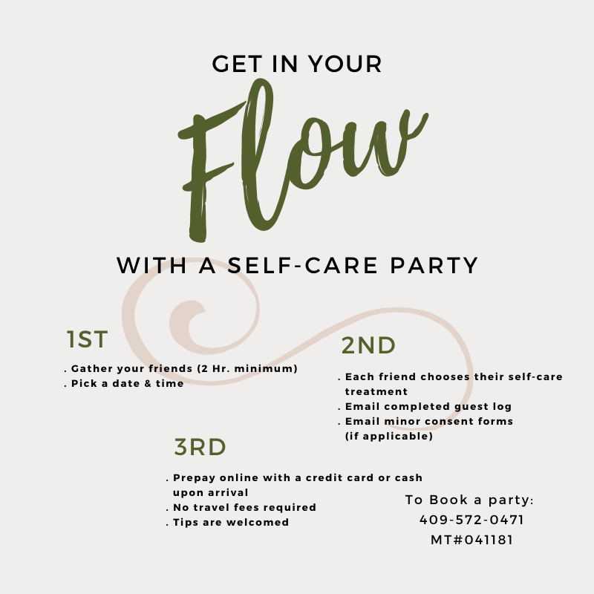
Guest Name____________________________________ Birthdate__________________

Email Address__________________________________ Phone #___________________

My Self-Care Treatment is:__________________________________________________

Guest Name____________________________________ Birthdate__________________

Email Address__________________________________ Phone #___________________

My Self-Care Treatment is:__________________________________________________

Guest Name____________________________________ Birthdate__________________

Email Address__________________________________ Phone #___________________

My Self-Care Treatment is:__________________________________________________

Guest Name____________________________________ Birthdate__________________

Email Address__________________________________ Phone #___________________

My Self-Care Treatment is:__________________________________________________

Guest Name____________________________________ Birthdate__________________

Email Address__________________________________ Phone #___________________

My Self-Care Treatment is:__________________________________________________

Guest Name____________________________________ Birthdate__________________

Email Address__________________________________ Phone #___________________

My Self-Care Treatment is:__________________________________________________

Minor Release Form

All persons under the age of 18 are required to have a parent or guardian fill out this form.

By signing below, you agree that you are the parent or legal guardian of the minor receiving massage treatment(s) from Kandi Champion, LMT, MT#041181. Unless you are present for the entirety of the minor’s treatment, you also agree to provide a copy of a state issued form of identification.

You also agree that you have completed the Intake Form and have informed the therapist of all medical diagnoses, symptoms, medications, and complaints associated with the minor receiving treatment(s).

PLEASE PRINT CLEARLY:

I ________________________________________, certify that I am the parent or legal guardian of _______________________________________, who is __________ years of age as of today. I have completed the Intake Form for the above-mentioned minor and informed the therapist of all relevant medical history and concerns. I understand the scope of massage therapy and that it is not meant to diagnose, treat, or cure any conditions and is not a replacement for standard medical care. I give permission for my minor child to receive treatments(s) from Kandi Champion, LMT, MT#041181 and agree to all the above terms.

Print Name ___________________________________________

Signature _____________________________________________
^{Date}

For a better understanding of certain terms, please see website tab ‘Terminology’ for more detailed information.

